Why some South Bay businesses are signing up to take on feral cats

1/7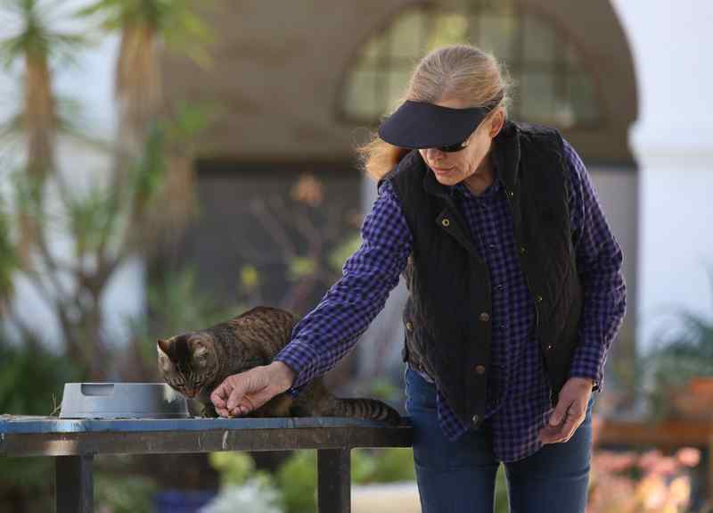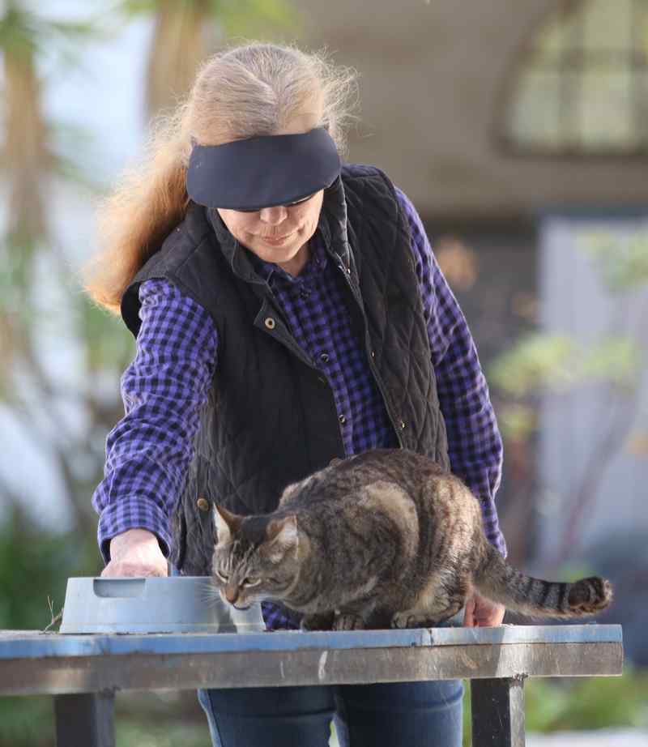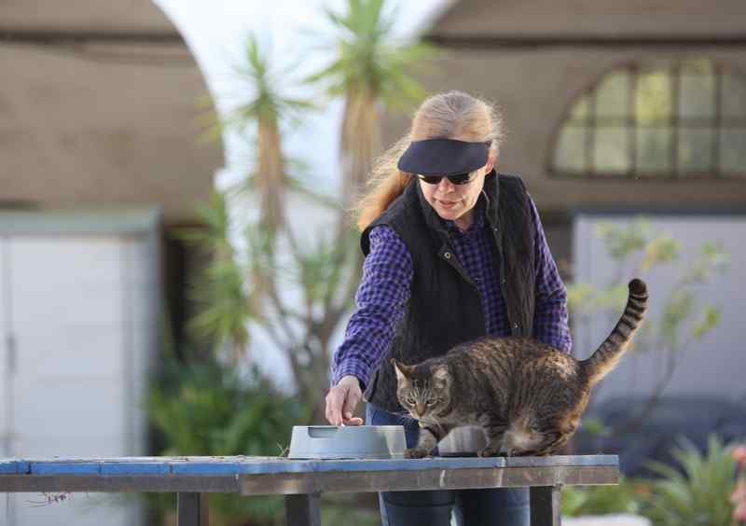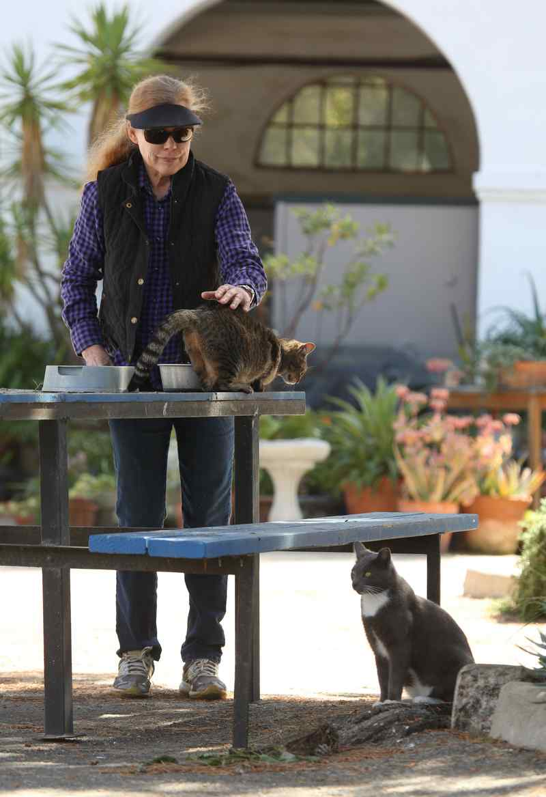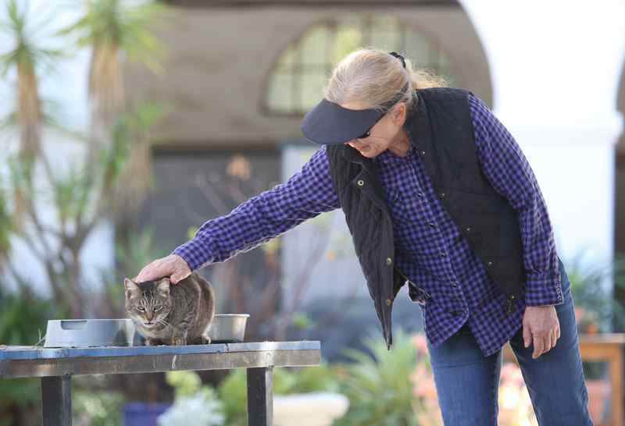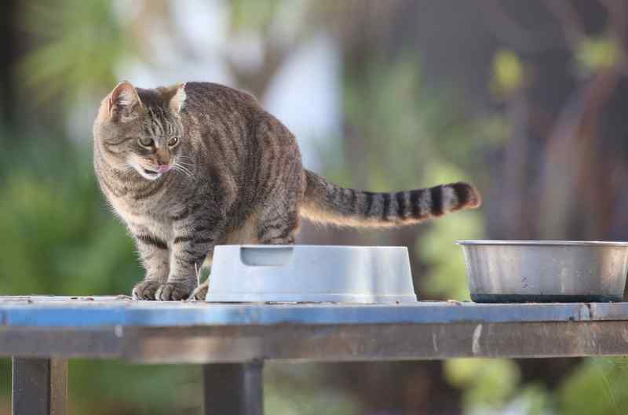 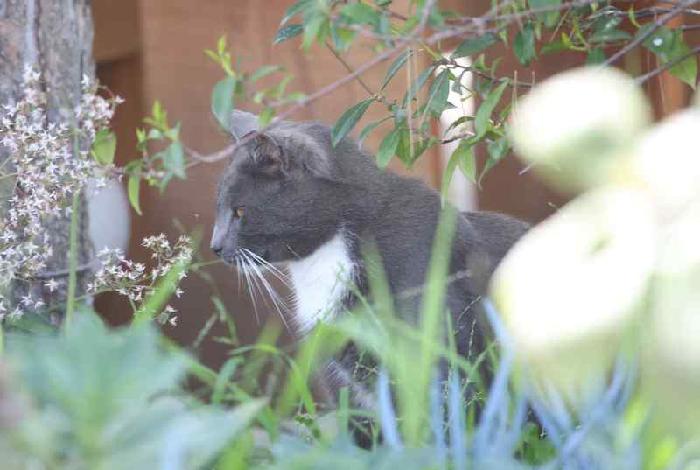

By Cynthia Washicko, The Daily Breeze
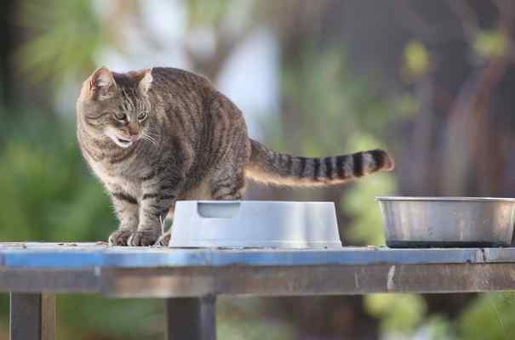Kitty Bungalow is a nonprofit that rescues feral cats and socializes them so they can be used as mousers for businesses. The Portuguese Bend Riding Club got a couple of the cats less than a year ago and now they say they've seen a vast improvement in the number of mice and rats in their barns. The owner of the club, Mousie one of two cats at the riding club. Chuck Bennett/Daily Breeze/SCNG
When Smitty and Mousie were first introduced to the Portuguese Bend Riding Club, they mostly kept to the cleared-out horse stall meant to be their new home.
Slowly, though, the rescued feral cats ventured out of the stall and made short work of the mice and rats around the club’s feed rooms and barns.
“They’re working beautifully,” club owner Lisa Wolf said.
Both cats came to the club from Kitty Bungalow Charm School for Wayward Cats, a nonprofit that, among other things, rescues feral cats from Los Angeles shelters and resocializes them to be used as mousers for businesses.
Back to School
The organization takes in feral cats up to about 16 weeks old for its Working Cat, or Trade Tech, program, said Shawn Simons, Kitty Bungalow founder and headmistress. The cats are kept in the cage-free facility, where a rotating mix of 80 volunteers work with the felines, often using food as bribes to create a positive association with humans.
The Working Cat program started last year, and, so far, it’s paired 125 cats that would have otherwise been euthanized with businesses like Wolf’s riding club and others that can use the cats for pest control.
In addition to the Working Cat program, the nonprofit also spays and neuters street cats to help control the population of feral cats around Los Angeles, Simons said, and they’ve adopted out around 1,300 formerly feral cats as pets.
RELATED: Proposed L.A. city policy would ban feeding feral cats near sensitive habitats
The range of volunteers interacting with the felines in the Working Cat program is key, because it helps break down the cats’ anxiety around people, Simons said. And that’s necessary, because the organization focuses on getting the kittens socialized as quickly as possible and moved onto a new home while they’re still young.
So far the organization has found success partnering with businesses such as horse farms, breweries and wineries — places where a working cat is a logical fit, Simons said, but she’s looking to expand its reach into other areas that could benefit from a working cat, such as industrial parks.
‘In the Walls’
Before she took in the pair from Kitty Bungalow, Wolf said the club had issues with mice and rats in and around their feed rooms and barns.
“We absolutely had a pest problem,” Wolf said. “In the courtyard they actually seemed like they were in the walls. We couldn’t, couldn’t, couldn’t get rid of them.”
At first, Wolf was hesitant to take on any cats at the riding club because of the coyotes that roam the Palos Verdes Peninsula.
The rescues from Kitty Bungalow would have been euthanized if they hadn’t been rescued though, so Wolf said she felt better about giving them a chance to live on the club’s acres of land rather than a certain death at a shelter.
“I called Kitty Bungalow and they said, ‘Well, this gives them a chance to run from a coyote, because otherwise they have no chance,’ ” she said.
So she asked the organization to send up some “very feral” cats and, a short while later, staff from the nonprofit arrived with four rescues.
It’s normal practice to bring at least three cats to a location, in case one or more run off once they’re free, Simons said.
That’s what happened at the riding club, where two of the four felines ran off once they were able. Wolf still sees one of them around the property every so often, though, and the remaining two adjusted to life as well-fed barn cats, Wolf said.
Cost savers
Other businesses around the South Bay and the state have taken advantage of the Kitty Bungalow program as well.
In Torrance, Monkish Brewing Co. took in one of the cats. Now Cleo, a gray-and-black tabby, has been mostly domesticated and spends his days as an office cat, a brewery staff member said.
The company’s Lost Cat brew was inspired by the feral rescue turned pet, according to the brewery’s Facebook page.
RELATED: Monkish Brewing joins the Torrance microbrewery fraternity
Others, including Torrance-based The Dudes Brewery and Saluti Cellars outside Sacramento, have taken in “graduates” of the Working Cat program to control rodents around the properties.
Cats have been used to control rodent populations for centuries, Simons said, and it’s a natural instinct that can be put to use for businesses looking to get rid of the pests without poison or traps. Even if a cat from the program isn’t inclined to life as a mouser, just having a feline around can help scare off mice and rats, she said.
Taking in a working cat is an economic boon as well, Simons said. Most businesses dealing with pests pay an exterminator to come out again and again, and that’s on top of the cost of replacing any damaged goods.
“(The exterminator service) costs a lot of money, for sure, plus anything that’s being ruined — there’s a great economic upside to this,” she said. “The cats work for a bag of kibble.”

