Portuguese Bend Horse Show Celebrates 60th Anniversary

by EDEN FIZULICH CONTRIBUTING WRITER
This summer, Peninsula Committee Children’s Hospital members celebrated the 60th anniversary of the Portuguese Bend Horse Show with a party in the historic courtyard of the Portuguese Bend Riding Club (PBRC). The highlight of the affair was the unveiling of a commemorative tile wall plaque (designed by Lisa Van Nortwick and laid and hung by Lazlo Reinhardt) in the arched entry to the elaborate Spanish barn. The plaque depicts the early days of the show which started in 1957 and was held for some 20 years at PBRC’s serene treelined grounds—originally the Vanderlip family’s private stables.
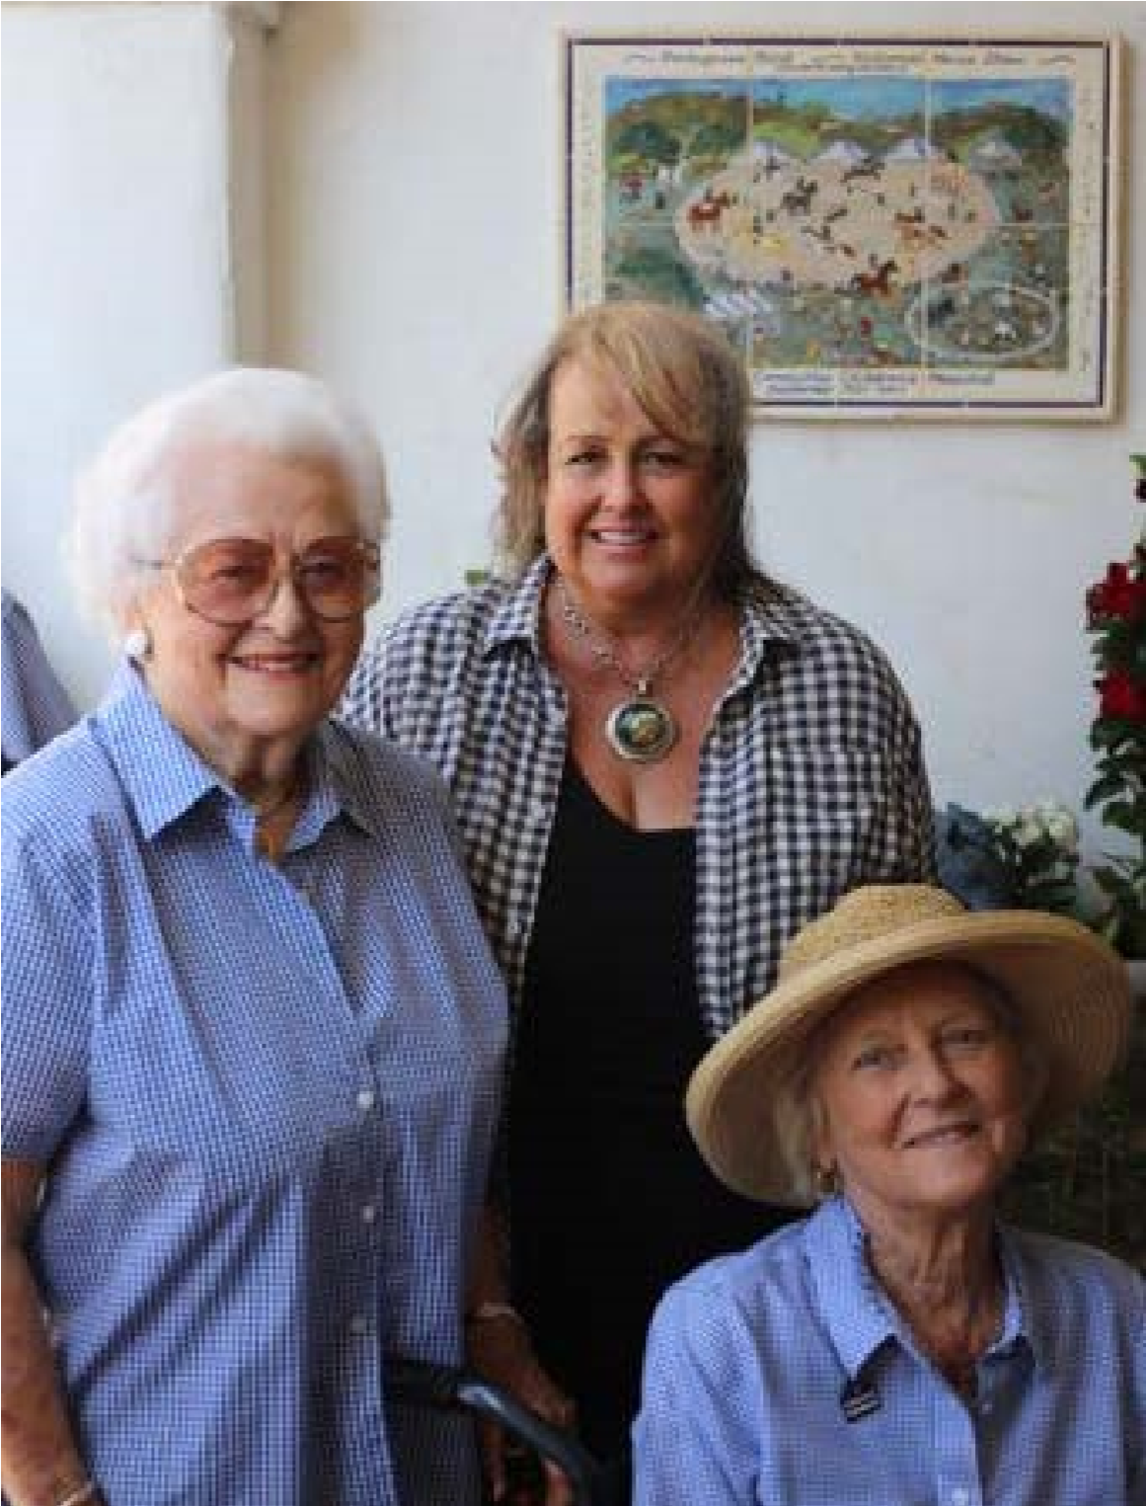

CREDIT: FLORA FAIRCHILD
(L-R) Betty Davidson, Lisa Van Nortwick, and Marion Scharffenberger at the unveiling of the tile plaque in July.
From early on, the A-rated show became one of the largest two-day events in the nation. It was televised for five years as one of the most important equestrian shows on the Pacific Coast major circuit. Thousands of spectators came to see classes in Hunters, Jumpers, Western Pleasure, Three and Five Gaited Saddle, Stock, Fine Harness, Tennessee Walkers, Welsh Pony English Pleasure, and lead even lines (where everyone got a blue ribbon). There were over 900 entries by 1967 with horses travelling from throughout California to attend.
Crowd-pleasing special acts included the Peruvian Pasos, the Onondarka Drill Team (now Foxfield Riders), and rodeo and movie trick rider/roper Monte Montana (Pro-Rodeo Hall of Fame 1994 inductee). Roy Register— then PBRC Manager and famous trainer of American Saddle Bred Show horses—rode locally-owned 1958
National Five Gaited Champion ‘Rose Lee Highland.’
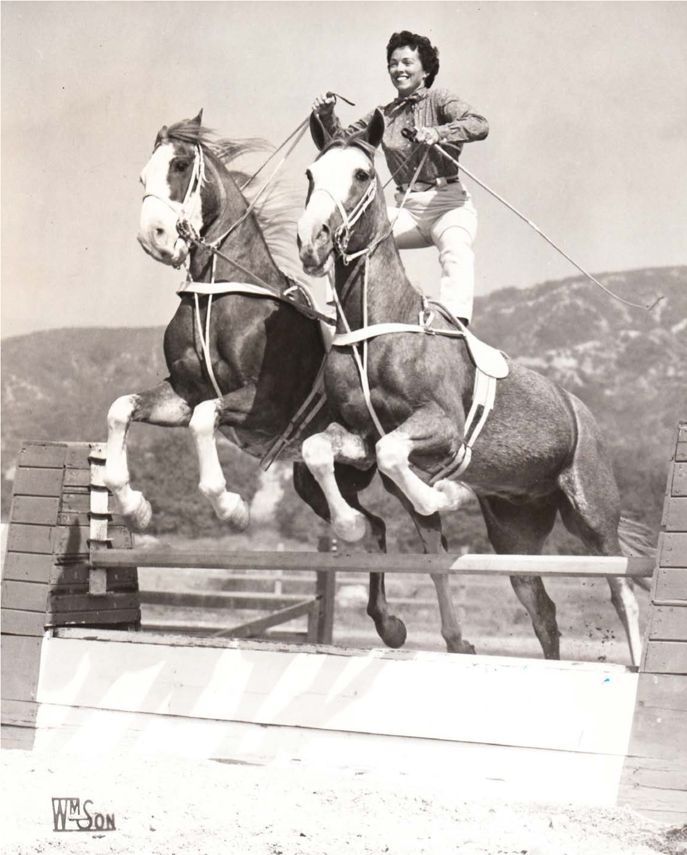

CREDIT: JOHN WILLIAMSON Pat Ommert riding Shortcake & Cupcake in the Roman Jump in 1957.
World-renowned Dressage rider Albert Ostermaier performed on “Crown Prince of the Western World” Lippizan stallion ‘Saffan’. Evan Shaw of Rolling Hills brought his prize collection of carriages complete with costumed riders each year, including a fire engine from the late 1800’s pulled by his own carriage horses. Trick rider and stuntwoman Pat Ommert (Cowgirl Hall of Fame 2016 inductee) and her famed Strawberry Roans ‘Shortcake & Cupcake’ performed the Roman jumping act she famously did in front of over 100,000 fans at the Coliseum that same year. She fondly recalls the “familyrun nature of the show, the amazing abilities of the ladies to raise funds for the hospital, and special feeling I had from the beautiful setting at the Portuguese Bend barn and buildings.” Pat’s husband, Dr. Willard Ommert, was the show’s head veterinarian. He donated his time every year and later served as the chief veterinary officer of the 1984 Olympics.
Founding committee member Betty Davidson remembers the show’s inception:
In the Spring of 1957 Mary Dukie, Volunteer Head of Associates at Children’s Hospital of Los Angeles, called Betty Learned, friend and local resident, to let her know that the Peninsula was in debt to the hospital for nearly $4,000 for free care it had provided to families in the area. A group of us got together to talk about how to repay that debt, and the idea of a horse show was born. From day one, all of our families and many friends came together to make happen, from painting the fences and jumps to hauling shavings. Feed, stalls, everything was done by volunteers. We even had a neighbor volunteer each year to clean the dozens of paintbrushes—and it was oil-based paint! With the immense help of Roy Register, the very first show beat the goal to repay the debt to the hospital. And it’s been a great run ever since!
and managing of the complex schedule and logistics of the show.
The history of the Portuguese Bend National Horse Show is a testament to the strong equestrian history of our community. We give a proud nod to our equine past and look forward to more to come! i
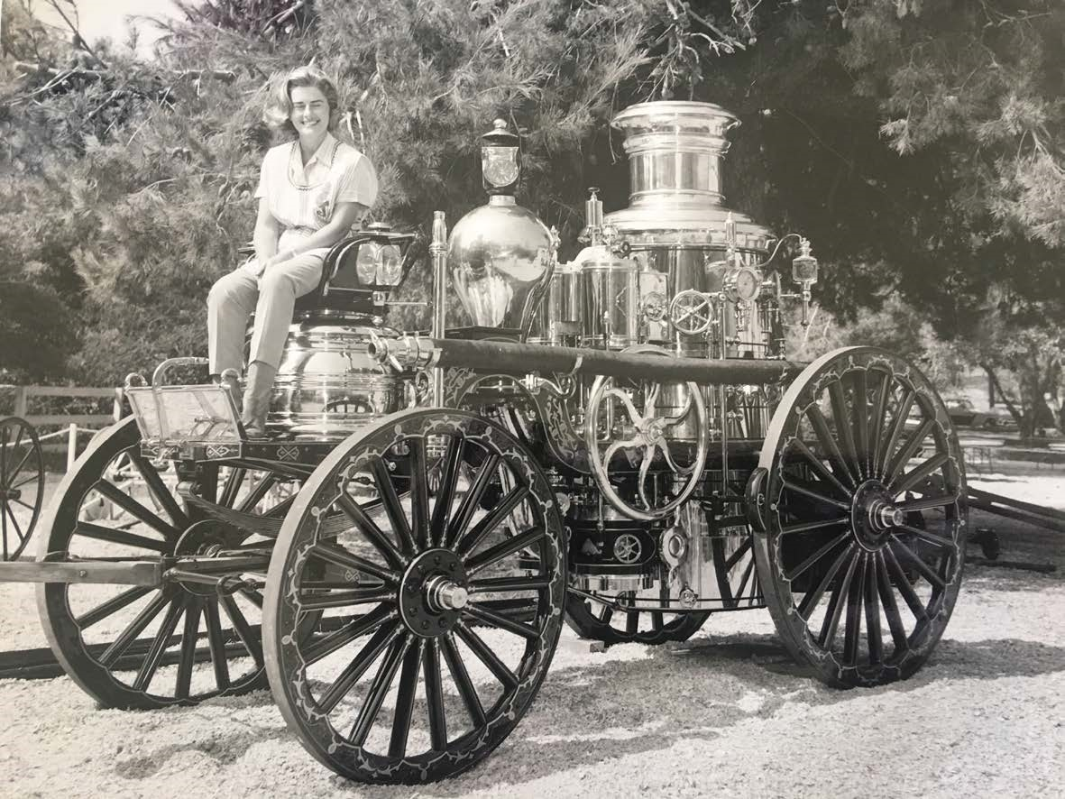

COURTESY: BETTY DAVIDSON ABOVE: Betty Davidson at the PB Horse Show sitting on Evan Shaw's fire engine from the late 1800’s. BELOW: Cover of the Palos Verdes Social Review from October 1972.
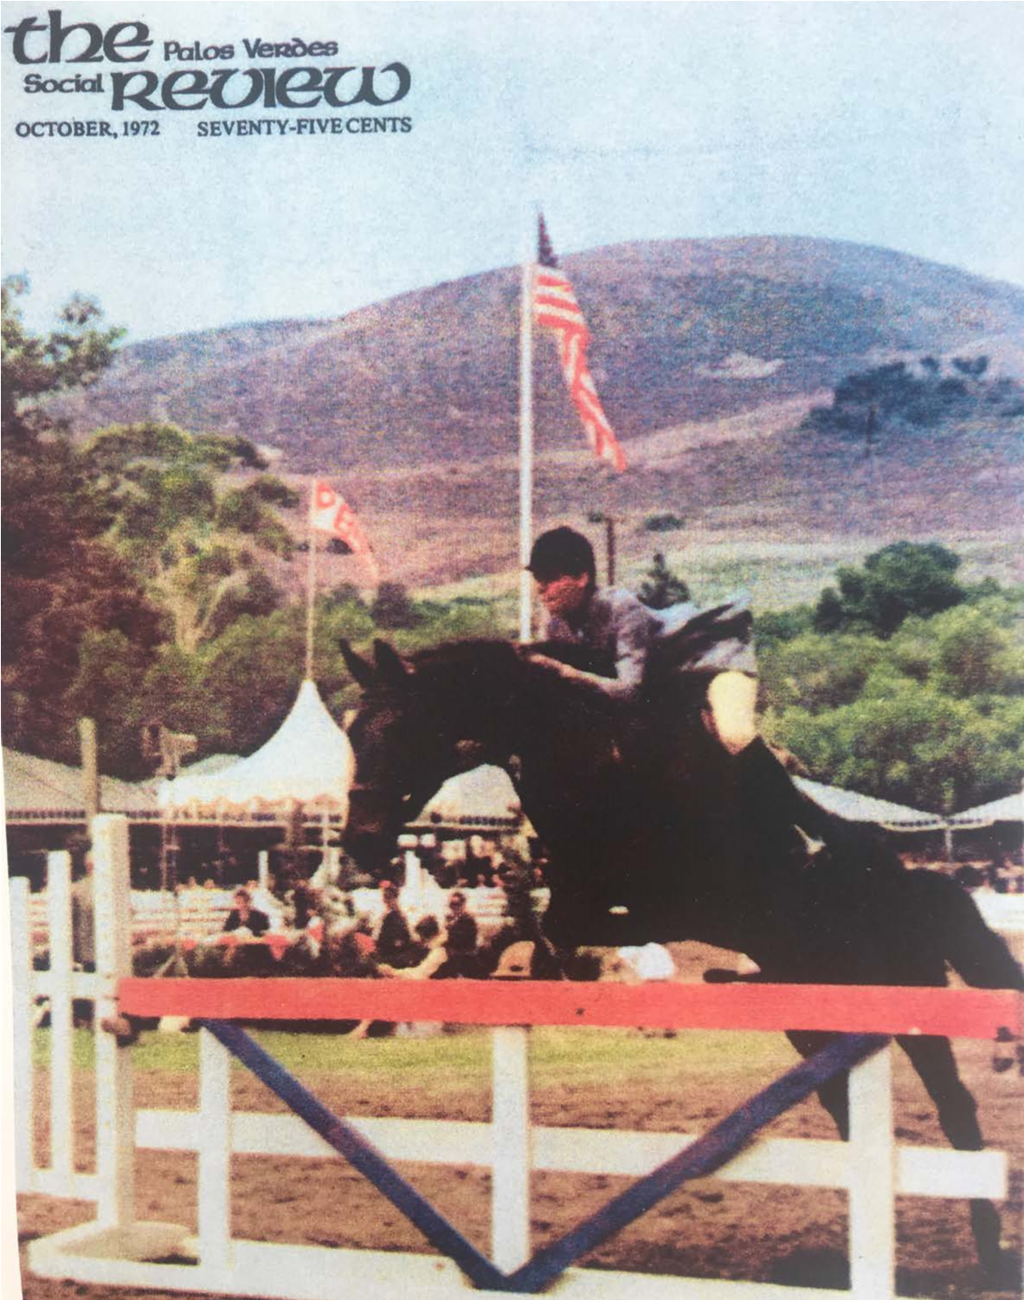

In addition to the show, the committee raised funds for the hospital through black tie “Saturday Night Suppers” at private homes in Portuguese Bend where guests purchased raffle tickets for items as elaborate as diamond brooches from jeweler Laykin et Cie of Hollywood fame. Entertainment acts included a ragtime piano player brought in from Cripple Creek Colorado.
From that one phone call sixty years ago the committee has to-date raised over $16 million for Children’s Hospital. In 2012, the show was given the Heritage Award by the US Equestrian Federation (of just 22 shows). USEF President Chrystine Tauber presented the award, highlighting the “tireless commitment of the committee” and describing the show as “a very special, time-honored tradition here in California.” The family tradition remains central to the show, as current president Carole Rowe shares:
We absolutely could not put on the show, the boutiques, booths, and children’s area without all the family involvement. There are now 170 members on the committee, all volunteers, who along with their spouses, children, grandchildren, and great-grandchildren dedicate some 15,000 hours each year to the planning, preparing, staffing

